# Overview

In this guided practice you will create and link a simple GPO and test its settings

# Objectives

* Be able to create and link a group policy object
* Be able to verify the operation of a group policy object

# Prerequisites

Guided practice – Creating Active Directory Objects is complete

# Scenario

Your organization is interested in centralizing the management of user and computer settings. It would like to do this using Active Directory and Group Policy. They would like you to test out the operation of Group Policy in the guided practice so that you can later provide a plan for using Group Policy to manage user and computer settings.

# Tasks

## Creating and Linking a Group Policy Object

**Creating and linking a GPO**

1. Loginto the **CIS256-DC1** virtual machine as the **abscorp\administrator.**
2. Open the **Group Policy Management** console (gpmc.msc)
3. Expand the **Domains** container
4. Right**-**click the **abscorp.com** domain and choose the **Create a GPO in this domain and link it here…** option from the context menu.
5. In the **New GPO** dialog box, type **No Recycle** in the **Name**: text box and click the **OK** button.
6. Graphical user interface, application

   Description automatically generatedRight-click the new policy and select **Edit** as shown in the figure.
7. Browse to the **User Configuration** node select **Policies→Administrative Templates→Windows Components→Desktop→Remove Recycle Bin icon from desktop** and **click** the **OK** button as shown in the figures below

1. Exit the group policy editor.

## Verify the GPO settings

One method of verifying group policy settings is by using the **Group Policy Modeling** **wizard**.

To verify Group Policy Settings using the Group Policy Modeling wizard, perform the following:

1. In the **Group Policy Management** console, right-click the **Group Policy Modeling** node and choose **Group Policy Modeling Wizard** from the context menu.
2. On the **Welcome to the Group Policy Modeling Wizard** page, **click** the **Next** button.
3. On the **Domain Controller Selection** page, verify **abscorp.com** is shown in the **Show domain controllers in this domain** and the **Any available domain controller**… **option** is **selected**. Click **Next.**
4. 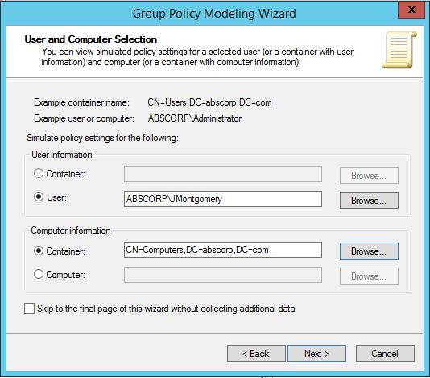In the **User and Computer Selection** page,
   1. In the **User** **information** section **select** the user **Joe Montgomery.**
   2. In the **Computer** **information** section, select the **computers** **container** as shown in the figure.
   3. Click the **Next**.
5. Click **Next** until you get to the **Summary** **of** **Selections** page of the wizard, note the options that you have for testing group policy settings. Click the **Next** button.
6. On the **Completing the Group Policy Modeling Wizard** page, click **Finish**.
7. You should now see the results. Note the information in the **Summary** page.
8. View the **Applied GPOs** on the **Details** page to verify that the policy was applied.
9. Select the **Settings** node on the **Details** page and verify the setting that is being applied.
10. You should see the figure below.

1. Exit the **GPMC.**
2. Logon to your client computer to verify the settings. **Note**: You may have to sign out and sign in to have the policy updated.

## Submission Requirements

1. **Download** the **grading** **script** from the assignment page to the **C:\Scripts** folder.
2. Check your lab by running the following command:

Invoke-Pester -Path C:\Scripts\GP13-Creating_and_linking_a_ Group_Policy.test.ps1

**Note**: You will see a security warning when running the script. Enter **R** to run the script.

If you want to see more detail, add **-Output Detailed** to the command. This may assist you with troubleshooting

Invoke-Pester -Path C:\Scripts\GP13-Creating_and_linking_a_ Group_Policy.test.ps1 -Output Detailed

1. You should not see any red in the output. Red in the PowerShell way of telling you that an error condition exists. Most of the time, the output will tell you what is wrong. If it is not obvious, contact your teacher and ask for assistance. You will be learning PowerShell during this term. **Correct** any **errors** you may have and run the script until all the output has no red. You should see the output like the images below:

1. Capture a snippet that shows the PowerShell Command and all its output. If you must use more than one snippet to capture the output, you must have at least **one line of overlap** in the snippets. The text in the snippets **must be legible** when pasted into the Word document. Paste the snippet(s) into a **new** **Word** **document.** Save the file as **Linking_GPO_*Firstname*_*LastName*** (where ***Firstname*** is your first name and ***Lastname*** is your last name).
2. **Upload** the **document** in the submission area of the assignment.